Appendix 1 - Installing Jenkins

# Download the latest version of Tomcat 9

Download the version of Tomcat relevant for your operating system from this page:

https://tomcat.apache.org/download-90.cgi

(For Windows, choose the 64-bit Windows zip, for other systems choose zip or tar.gz)

Expand the contents of the downloaded zip file into a suitable folder on disk (e.g. c:\tomcat)

# Download Jenkins Generic Java Package (.war)

Find the Long-term Support (LTS) version of the Jenkins Generic Java Package from this page and download it:

https://www.jenkins.io/download/

The file downloaded should be called **jenkins.war**

# Setting up the Tomcat Server

1. Open a terminal or Command Prompt
2. Navigate to the /bin folder in the extracted apache folder
3. For Windows...

* type the command startup.bat
* If a pop-up asks for permission to let Tomcat to go through firewalls, say yes

1. For MacOS:

* Change the ownership of the apache folder using the command  
  sudo chown -R <your_username> /<apache_folder_name>
* Change the permissions in the **bin** folder using the command  
  sudo chmod +x /<apache_folder_name>/bin/*.sh
* With the terminal pointing to the **bin** folder type the command startup.sh

1. Some logging should be done in the console.
2. Navigate to <http://localhost:8080> in your browser to check to see that the server is running.

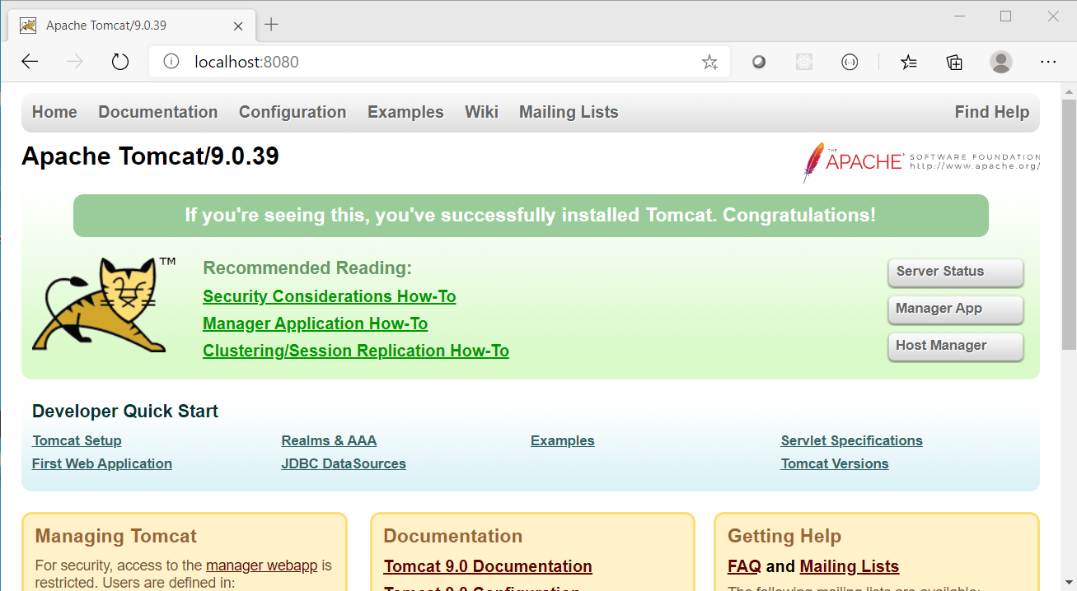

# Installing Jenkins

1. Copy the jenkins.war file you downloaded earlier into the <apache_folder_name>/webapps folder
2. A folder called Jenkins should be automatically generated
3. Navigate to <http://localhost:8080/jenkins>
4. You should see the Jenkins login page

# Initially Setting Up Jenkins

1. Jenkins (now) requires you to provide the admin password when first accessing the server. Follow the instructions on the screen to retrieve it.

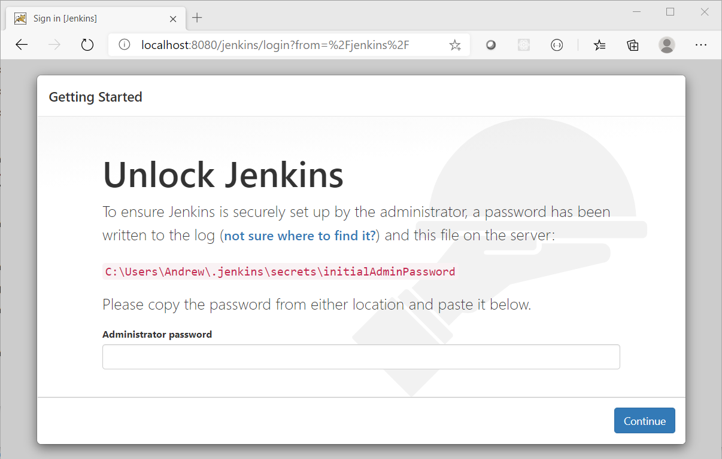

1. Obtain the initial admin password and copy it into the input in the window and click Continue

* For Windows, use the type command followed by the appropriate path (as shown on screen) for your system
* For MacOS, locate the file through Finder and open it with ‘Text Editor’

1. When the next screen shows, you will be prompted to decide which plugins to install initially

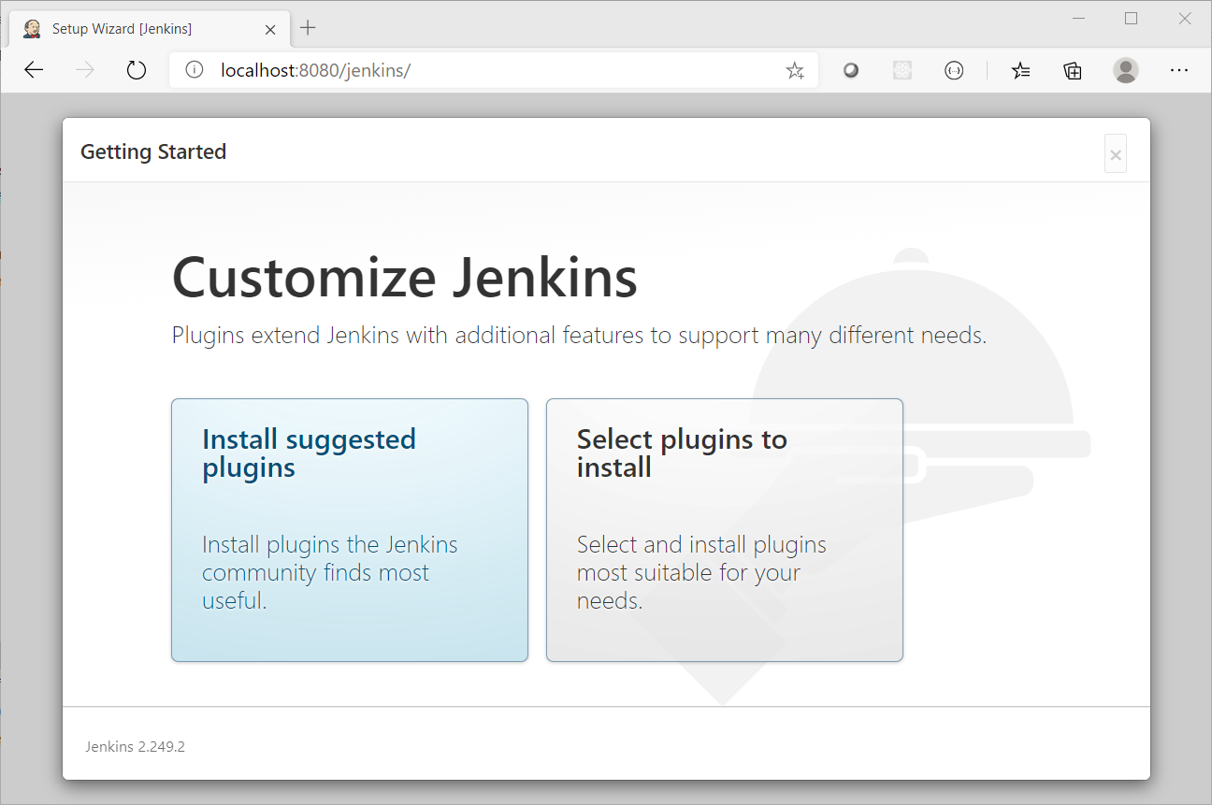

* Click Select plugins to install
* Do not remove any of the defaults
* Add the following by checking their box (you may find it useful to use the search box on the page to filter the list down to find each one)
  + JUnit - allows JUnit tests to be run
  + BitBucket - allows integration with a BitBucket repository
  + Matrix Project - a multi-project configuration tool
  + WMI Windows Agents - allows you to setup agents on Windows machines (not required on MacOS)

1. Click Install and wait for the process to complete

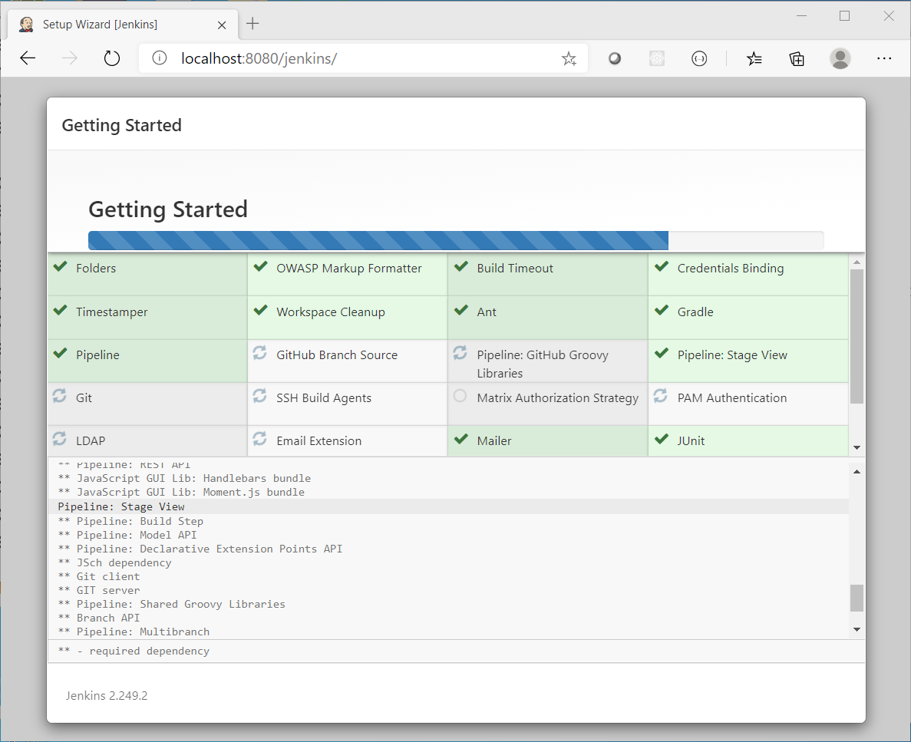

1. When the installation completes, create a user called root with a memorable password, click Save and Finish

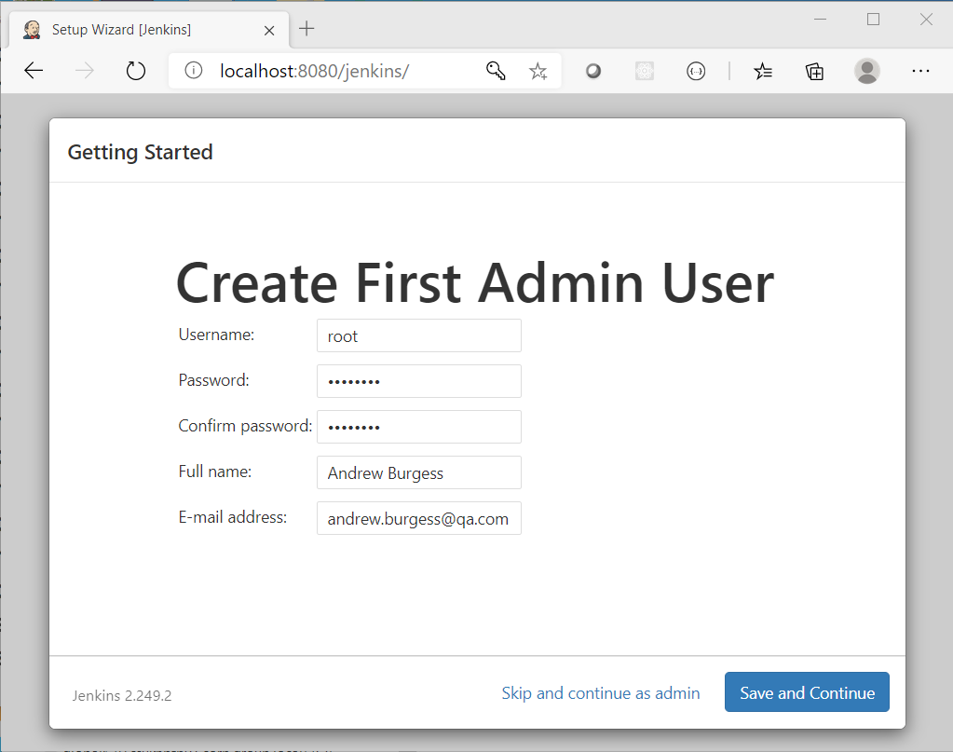

1. Leave the default URL and click Save and Finish again

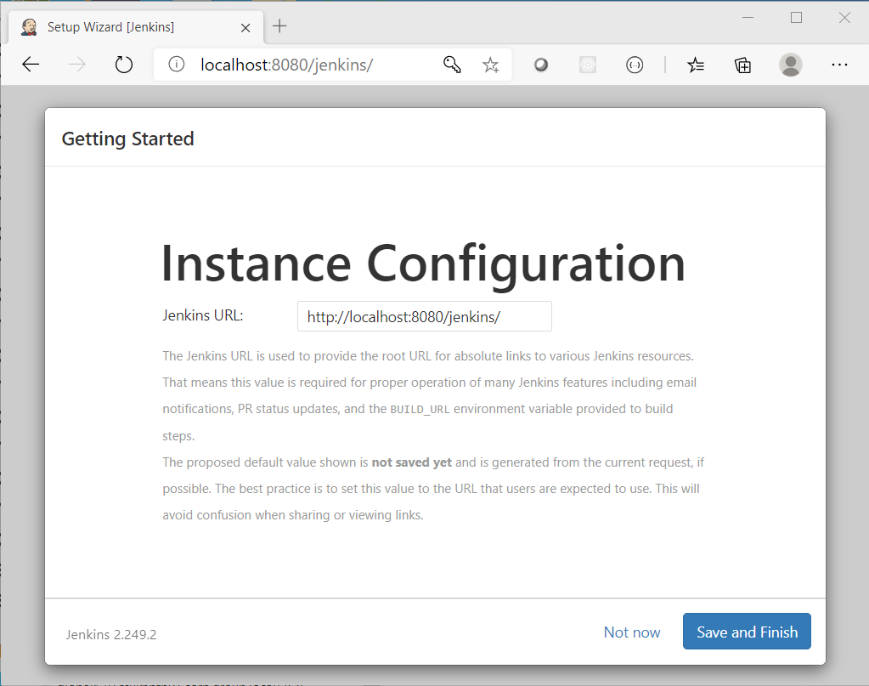

1. Click Start using Jenkins

If Jenkins looks like it is frozen when you click save and finish, refresh the page and continue as admin. The password will be the one you retrieved earlier from the file, but this can be changed via the dashboard later.

You should now be presented with the dashboard. If it looks like the installer has crashed, then refresh the page. If this keeps happening, click Continue as admin rather than add a new admin user.

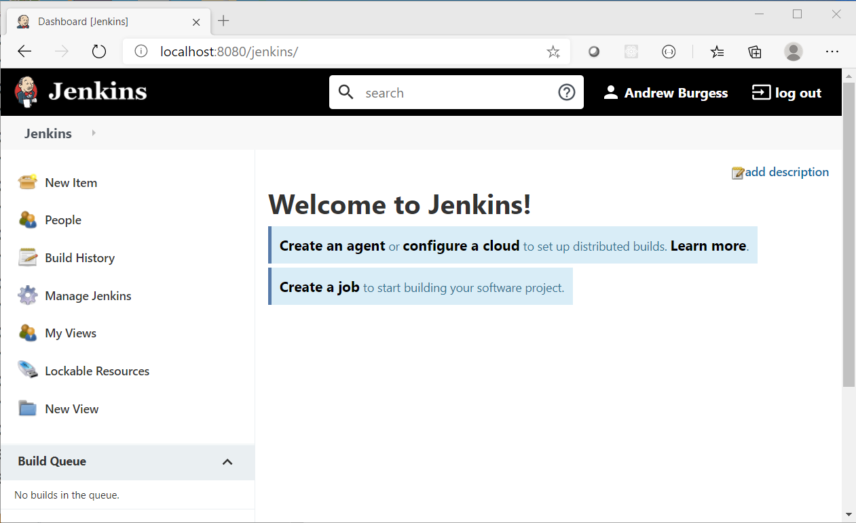

# Installing Build Plugins

1. Click Manage Jenkins from the menu on the left of the screen
2. Find Manage Plugins from the list in the middle of the screen and click on it

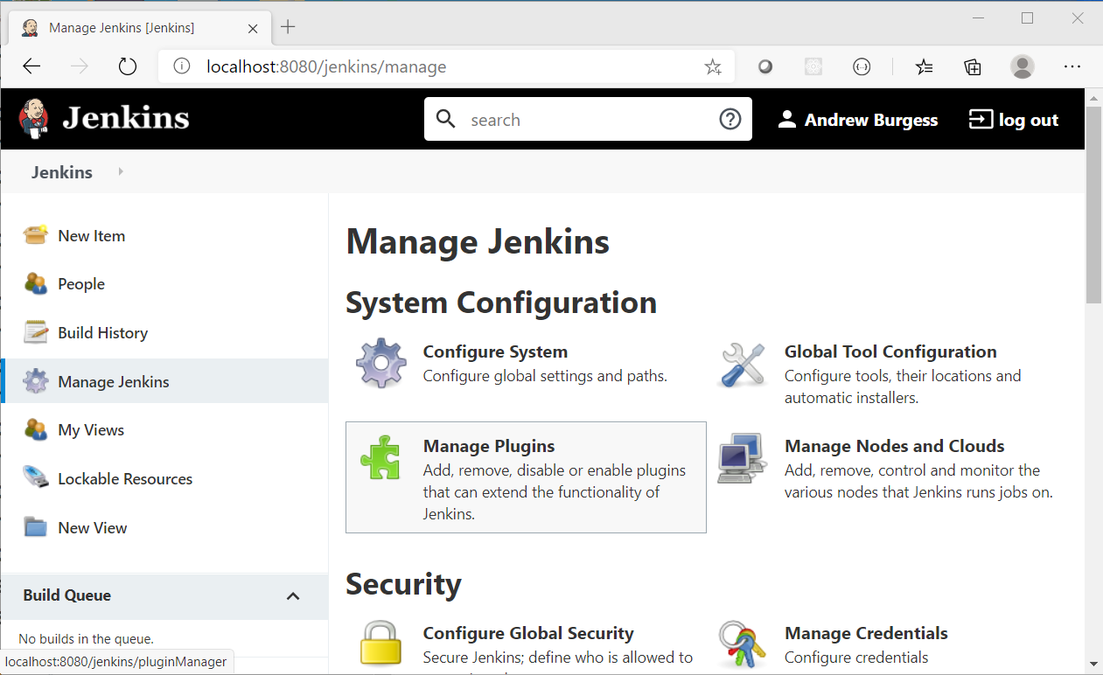

1. Click on the Available tab ad then search for Maven Integration

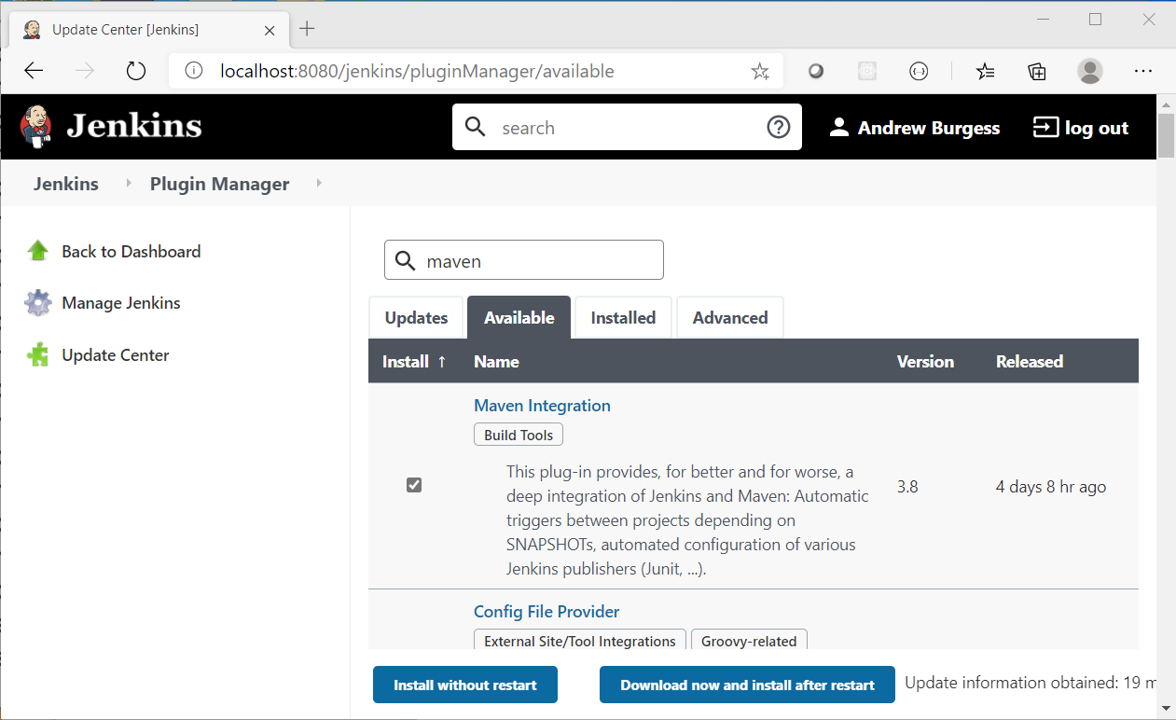

1. Tick the Maven Integration box
2. Click Download now and install after restart
3. Go back to your command / terminal window and stop Tomcat (ctrl-C)
4. Restart Tomcat, the same way you started it before
5. Refresh your browser, and log in again to Jenkins, using your root user credentials

# Enabling Maven

1. Click Manage Jenkins from the menu on the left of the screen
2. Find Global Tool Configuration from the list in the middle of the screen and click on it again.

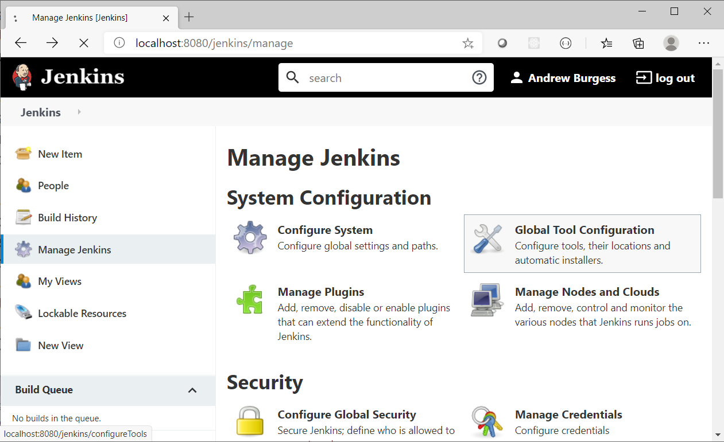

1. Scroll down until you find the Maven section and click Add Maven

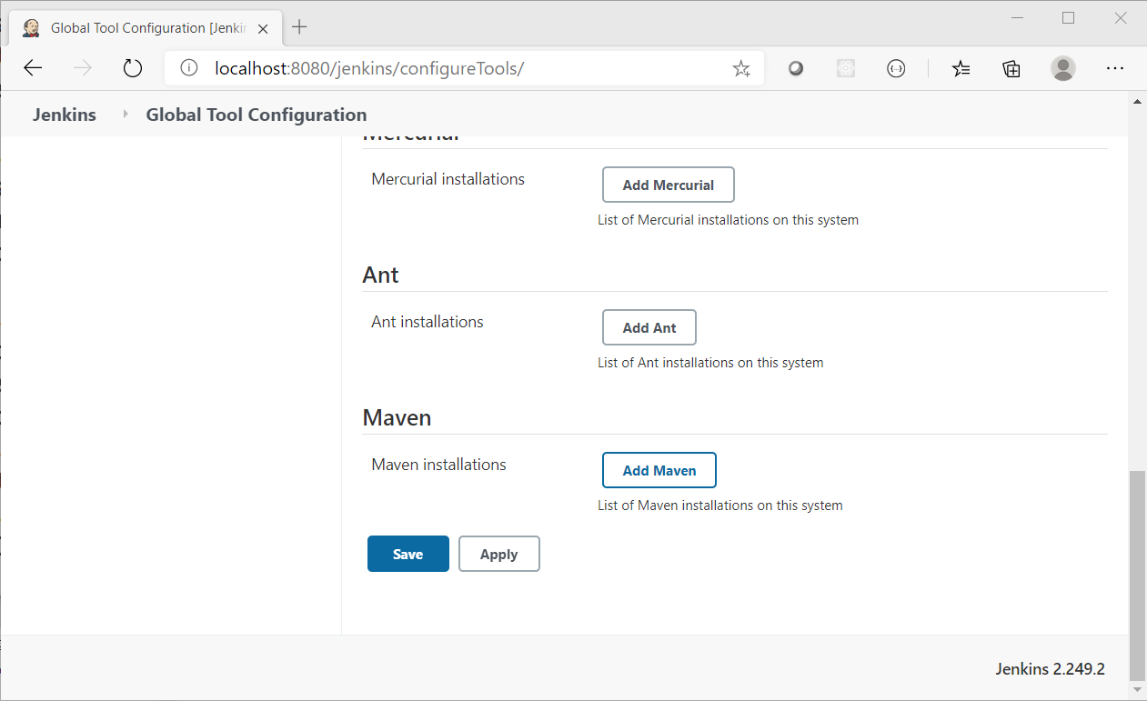

1. In the Name input box type M3 and click Save

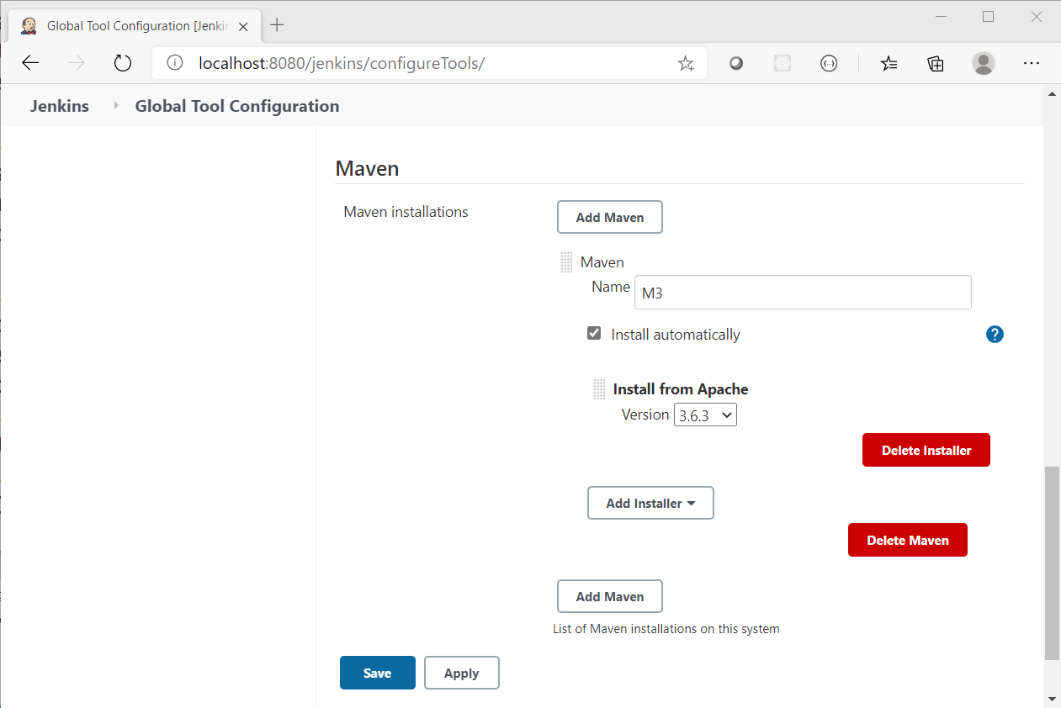

1. You will be returned to the Manage Jenkins screen - it is now configured to build Maven jobs!